CHAPTER I
THE PROBLEM AND ITS BACKGROUND

INTRODUCTION
Technology is becoming prevalent in most aspects of our lives. It phenomenally improves our society today most especially in the field of information and communication. Today in spreading the news we use technology such as Computer, Television, and Cellphone, in social media such as Facebook, Instagram, Twitter and Viber to get the news.
News Media for Taguig City University will help the student to provide information, announcement, and news regarding the school activities and events. The News Media will be all in one where all the organizations will be able to upload their content and stories for students of Taguig City University to be updated.
In Binary search, also known as half-interval search, logarithmic search, or binary chop in computer science, is a search algorithm that finds the position of a target value within a sorted array. The binary search compares the target value to the array's middle element.
Binary Search Algorithm in Steps: We basically ignore half of the elements after just one comparison. Consider x in relation to the middle element. We return the mid index if x matches the middle element. Otherwise, if x is greater than the mid element, x can only be found in the right half subarray following the mid element.
A keyword search will seek for the specified terms across the document. When you do not know the typical topic heading, doing searches using keywords is a viable alternative to conducting searches using that heading. When you just have partial information on the title or author of anything you're looking for, you may use a keyword search.
Inverted indexing is a method that is frequently used by search engines in order to determine which websites include the phrase that is present in the user's query. This is done in order to provide relevant results to the user. In the most fundamental sense, the functioning of an inverted index is based on the search of a phrase in the list that is maintained by the search engine.
New media does not always refer to a specific mode of communication. Some forms of new media, such as an online newspaper, are also "old media" in the form of a traditional printed newspaper. Other forms of new media, such as a podcast or smartphone app, are completely novel. It becomes even more difficult to define when you consider that, as technology advances, the definition changes.
Any digitally delivered media, from newspaper articles and blogs to music and podcasts, is considered new media. Any internet-related form of communication, from a website or email to mobile phones and streaming apps, can be considered new media.

BACKGROUND OF THE STUDY
Technology is a vast medium that can be used in the field of news media platforms. From the news we read online like facebook. It was designed to connect users and help them share and engage with content and media encompasses all of the various ways a message is communicated. The media we consume has the ability to inform, educate, entertain, and persuade us. It has an impact on how we see and think about ourselves and the world around us.
In the Colleges and Universities are agents of developing student’s knowledge skills and abilities in preparation to having good education, which produce good leaders, who will lead in the Country. We are centralized on social media where we can interact, socialize, communicate and connect to other people. Social media continue to find ways to update in everything happening to the world. It is also a platform of news media.
The News Media for Taguig City University will help users to provide information, announcement, and news regarding the daily happenings of a specific event. The News Media will be all in one where all the organizations will be able to upload their content and stories. Having this system, it will allow the users, especially students of Taguig City University to be updated.
Researcher aims to provide a system based on a web that can help in terms of media technology (News Media for TCU). This study contains a topic about Management System, Enhancement for Security. According to (Krueger Robert, 2018), We also see a lot of journalists making the transition to communications, as well as high school teachers taking the next step by aspiring to become a professor at the college level.
The researchers came up with an idea to create a News Media Website to help students and organizations to compile information and track the development of their organization. The researchers proposed this system because no news media existing in institutions has a system that can track progress, view announcements, update, save images to the database. As we observed in any education institution, they have been relying on using other platforms like facebook to collect and save the information, news, images, and stories. By creating an all-in-one platform, students and other users will not now rely on those platforms mentioned.

PROJECT CONTEXT
This project provides a solution for researchers and the institution to improve media services. As technology advances, there is a change in the way news media systems operate. Traditionally, announcements, news, and stories records were based on using facebook pages. The purpose of this project is to help the institutions and organizations like the university of Taguig City to upload news, manage and keep the information records. The News Media System is designed for records management to give the organizations stories credibility and to have organized their work.
The concept of this study is based on existing media compilation, where organizations who were collecting and compiling the information, news, and announcement on individual facebook page are now seeing them on the website. The researcher will conduct a survey interview with the organization's officers who are currently taking computer science in Taguig City University. This study will assist the CICT faculties of Taguig City University in better understanding and track the news records of organizations.
- Electronic News Media
This project, which is a web-based application and goes by the name News Media for TCU was designed and created with PHP, MySQL, and Bootstrap. The pupils will have the ability to access the data online while this also serves as a repository for the information.
- Binary Searching
Binary search is a 'divide and conquer' algorithm that requires sorting the initial array before searching. It is called binary because the algorithm divides the array into two halves. A binary search will initially examine the item in the middle of the array and compare it to the search terms.
- Keyword Based
Researching keywords enables you to determine which ones are the most effective to target and offers vital insight into the questions that members of your target audience are really inputting into your system.

PURPOSE AND DESCRIPTION
The News Media Management System Project is a web-based application that automates the existing manual system with the help of computerized equipment and full-fledged computer software, meeting their requirements, so that their valuable information can be stored for an extended period of time with easy access and manipulation. The necessary software and hardware are readily available and simple to use.
This project, like other news media sites, allows users to read blogs of various categories. He or she can add categories, manage posts, and delete categories from the admin panel. The design is very similar to the WordPress blogging theme. The site administrator can add a number of posts to the categories of their choice, and the blogs can also be viewed by selecting a specific category. This project's design is simple, and the user will find it easy to understand, use, and navigate.

OBJECTIVES OF THE STUDY
This study objective is to design and develop the News Media Website for Taguig City University students and organizations.
- To guarantee the safety of the accounts and information.
- To assist students in keeping track of activities, news, and announcements related to their specific organization.
- To make information such as news, announcements, and photos easily accessible.
- To develop a keyword-based search that uses binary searching to locate specific suggestions without entering the website's title, news, published date, or other information.
- To improve the password security of each account, admin, sub-admin, and student.
- To assess the performance of the developed News Media with Web-based application using criteria based on ISO 25010 by the respondents in terms of:
- functional suitability,
- reliability,
- usability,
- compatibility,
- security,
- maintainability, and
- portability
Conceptual paradigm
Articles, Department & Organization

Software Requirements:
Browser
Git Version
XAMPP
PHP
Visual Studio Code
XDebug PHP Extension

Hardware Requirement:
PC Unit/Laptop (Core i3)
Review of Related Literature and Studies

System Development Cycle (SLDC)
Planning
Analysis
Design
Development
Testing
Implementation
Maintenance

INTERACTIVE NEWS MEDIA FOR TAGUIG CITY UNIVERSITY USING KEYWORD BASED BINARY SEARCH ALGORITHM

FEEDBACK

Figure 1. Conceptual Paradigm
Figure 1 illustrates an integrated framework that can be used to develop and investigate student engagement patterns and the inclusion of news media in educational blogs. The concept of self-directed and reflective learning served as the conceptual foundation for the framework, which was then utilized to analyze the blogging activities of undergraduate students within the context of a specific course.
In response to the rapid expansion of modern media resources like social media, digital channels, and electronic news sites, which together present individuals with an overwhelming amount of information, headlines, new technologies, and varying opinions, media and information literacy (MIL) has become a societal necessity. Because they will be the ones to spread the news and share their opinions with the world, it is vital that the next generation learns to engage with a variety of media.
To facilitate the creation of more complex systems by groups of developers, the SDLC is broken down into distinct phases. Teams and their models for software development have evolved over time in an effort to keep up with the rapid pace at which new versions of software can be completed and released. As a result, software development has perpetually sought means to combine or shorten the SDLC phases as frequent requirement changes have become a requirement in and of themselves.
Agile Software Development Life Cycle, also known as Agile SDLC, is an alternative to the conventional software development life cycle, which places more work on the shoulders of software development teams at the beginning of the process. One of the reasons for this is the longer time periods that are characteristic of conventional cycles; most newer and smaller businesses do not have the financial runway to wait for so long. They are confronted with the unpleasant reality that their rivals may beat them to market with a completed product or that their clients may have already moved on to the next solution with a shiny new object.

SCOPE AND LIMITATION OF THE STUDY
This study will focus on how well Taguig City University's news media website keyword-based searching works for each organization. It included information about current campus activities, events, news, and announcements. It helps the students and staff to know the information and latest news to be posted on the News Media Website. The researchers' system will benefit both institutions.
The News Media Website doesn’t have a comment section it is only for viewing the news and announcement. Only authorized personnel can manipulate the system.

SIGNIFICANCE OF THE STUDY
The following are the people or organizations that will benefit both the study and system:
Organizations - They are the primary focus of the News Media Website's establishment in order to have access to it. The website will be able to store news and announcements, including photos.
Students - By granting access to the website, Taguig City University students can view and be updated in their specific organization as well as in other organizations.
Institution - By providing modern technological advantages, this research will benefit the institution, professors, and students. Developing a system for this type of institution will give you a significant advantage in any other institution.
The Future Researchers - The completed news media website will assist them in providing a foundation for the evolution of this problem, which they can use as a reference for future studies and relevant issues.

OPERATIONAL DEFINITION OF TERMS/VARIABLES
In order to give the readers clear understanding of the study, the following terms are hereby defined conceptually and operationally.

News Media Website (NewsGrid) - Is an electronic that provides the announcements, information and news the daily happenings of a specific event.
Database - is a collection of information that is coordinated so that it can easily be accessed, managed, and updated. In one view, databases can be classified according to types of content.
Administrator - A person whose job is to manage a company, school, or other organization.
Author – A sub-admin person whose job to manage writing articles, uploading of notices and the creation of stories for each specific department.

CHAPTER II
REVIEW OF RELATED LITERATURE AND STUDIES
This chapter presents the relevant literature and studies that the researcher considered in strengthening the importance of the present study. It also presents the synthesis of the art to fully understand the research for better comprehension of the study.

FOREIGN LITERATURE
Media operations: a reorientation of newsworker categorization
As according Allie Kosterich. (2021) in his research “Media operations: a reorientation of newsworker categorization” the introduction and popularity of digital and social media has forever transformed the news media industry, particularly the overall production and distribution of hard-copy newspapers. Much of the scholarship on the transformation of the news media industry tends to focus on the phenomenon from the perspective of the journalist and how the process of journalism itself is changing. However, this work frequently overlooks how the process and laborers of newswork are more profoundly affected. As per to (Maeyer, 2019) a computer program used by news organizations or individuals to create, edit, organize, and publish journalistic content. The origins of modern-day CMSs date back to the process of newsroom computerization that started in the 1960s and to technological developments in web publishing in the 1990s. The latter have led to the creation of software that allows nontechnical users to easily publish content on the Web (blogging software and social media platforms). Consequently, the development of CMSs can be understood as a process of remediation, that is, the operation through which “new” media incorporate “old” media in a series of refashionings: modern-day CMSs still bear some traces of previous technological systems, as exemplified by the protean existence of the slug, a term that originated in the hot-type era and has carried into today’s digital software terminology. More specifically, studying the CMS draws attention to issues related to the institutionalization of journalistic workflows (that become ossified in digital technologies), newsroom technologies constituting a complex system, the evolution of professional roles and hierarchies (and consequent power relations), as well as the agency and relative autonomy of software.
The research of the application of the binary search algorithm of Radio frequency identification (RFID) system in the supermarket shopping information identification.
Wu, L., Liu, S., Zhao, B. (2019) in his article ‘’The research of the application of the binary search algorithm of Radio frequency identification (RFID) system in the supermarket shopping information identification,’’ discussed that the traditional bar code scanning in supermarkets is inefficient, which has been unable to meet the further development of a supermarket. To meet the needs of quick shopping in supermarkets, binary search algorithm has been proposed to prevent from anti-collision, which makes it faster to scan and identify the goods. On this basis, the goods which have not been checked out will be scanned again to obtain security. Besides, it plays an important role in the supermarket shopping system to achieve the functions of self-purchase and membership scheme. For the RFID supermarket shopping system, the test of the checkout efficiency, product recognition rate, and security were done. The result showed that the binary search algorithm had good accuracy in the RFID supermarket shopping system. The result also proved the rationality of the RFID supermarket shopping system, which can meet the daily needs of supermarkets. The method was applying the emerging technology into the traditional supermarket shopping system, which improved the profitability and management level of supermarkets.
Approximate nearest neighbor binary search algorithm for hybrid data over wireless multimedia sensor networks (WMSN) blockchain
In addition, Liu, H., Wei, X., Xiao, R (2018) this article ‘’approximate nearest neighbor binary search algorithm for hybrid data over wireless multimedia sensor networks (WMSN) blockchain,’’ discussed that in order to prevent sensitive data tampering in the application of security monitoring, intelligent traffic, and other sensitive Internet of Things, the research on WMSN application system based on blockchain and Inter Planetary File System (IPFS) is of great significance. However, WMSN data are characterized by high dimensionality, large scale, and multiple types, so it is challenging to search WMSN data efficiently over blockchain system. The wireless multimedia sensor network (WMSN) is a new wireless sensor network developed based on wireless sensor networks (WSN) with multimedia data such as videos, audios, and images. To date, WMSN has been widely used in security monitoring, intelligent transportation, environmental monitoring, etc. We should prevent some sensitive application data from tampering, such as supervision data of farm products and violation evidence data from intelligent transportation systems. At present, a cutting-edge idea is to protect highly sensitive data by using currently hot technologies of blockchain and IPFS to build blockchain systems based on WMSN. Therefore, the solution of multimedia data search will be basic design in the development of WMSN blockchain systems. Generally, after preprocessing of WMSN data, we filter massive data from the same network through search operations based on multimedia data, to obtain data results similar to query objects. It can be seen from literature that quick querying of high-dimensional massive datasets has shown great potential.
An Optimised Binary Search Algorithm
In the research of (Amannah & Michael, 2017) very common application for computers is storing and retrieving information. For example, the telephone stores information such as the names, addresses and phone numbers of its customers. When directory assistance needs to get phone number for someone, the operator must look up that particular piece of information from among all data that have been stored. Taken together, all of this information is one form of a database which is organized as a collection of records. As the amount of information to be stored and accessed becomes very large, the computer proves to be a useful tool to assist in this task. Over the years, as computers have been applied to these types of tasks, many techniques and algorithms have been developed to efficiently maintain and process information in databases. The processes of “looking up” a particular data record in a database is called searching, it is also the way to look for something in a list. Looking up a phone number, finding a website via a search engine and checking the definition of a word in a dictionary all involve searching large amounts of data. In Computer Science, a search algorithm is an algorithm for finding an item with specified properties among a collection of items. The items may be stored individually as records in a database; or may be elements of a search space defined by a mathematical formula or procedure, such as the root of an equation with integer variables; or a combination of the two, such as the Hamiltonian circuits of a graph. In order to do an efficient search in a database, the records (items) should be maintained in some order-mostly referred to as data structure. A data structure is a particular way of storing and organizing data in a computer so that it can be used efficiently. Different kinds of data structures are suited to different kinds of applications, and some are highly specialized to specific tasks. In a linear data structure, searching data involves determining whether a value (referred to as the search key) is present in the data and, if so, finding its location.
Two popular search algorithms are the simple linear search and the faster but more complex binary search. Linear search is the simplest search algorithm that is applied in finding a particular value in a list that consists of checking every one of its elements, one at a time and in sequence, until the desired one is found. Linear search algorithm is a special case of brute-force search. Its worst case cost is proportional to the number of elements in the list; and so is its expected cost if all list elements are equally likely to be searched for. Therefore, they also impose additional requirements. Linear search is usually very simple to implement, and is practical when the list has only a few elements, or when performing a single search in an unordered list. Binary (half-interval) search algorithm finds the location or index of an item in a sorted set of data elements by comparing the key to a designated middle element; and if not equivalent, repeatedly constraining the middle element comparison to the smaller relevant half of the set until a match is obtained, or the list is exhausted of which an invalid index will be returned to signify it found no match with the key. The binary search algorithm is more efficient than the linear search algorithm, but it requires that the array be sorted. The first iteration of this algorithm tests the middle element in the array, if this matches the search key, the algorithm ends. In the worked on analysis of linear and binary search algorithm. The aim of this study was to compare and contrast the linear and binary search algorithm. Here, linear search is simple to implement in a larger time while searching an item, where as binary search algorithm searches an item with smaller time as compared to linear search. They were limited in discussing about the run-time analysis (order of growth) and Big-O’ notation also the best case, average case and worst case complexity. The method used in solving the problem of the work was visual basic to analyze the different metrics of linear and binary search algorithms. In conclusion the optimized Binary Search will thus enable search to be performed with faster time, thereby ensuring search efficiency; however, it will exhibit the same runtime as the Binary Search algorithm if the vale searched for is within the feasible search space.
LOCAL LITERATURE
Internship recommender services and management system utilizing fuzzy search algorithm
According to Estilo (2019) the “Internship recommender services and management system utilizing fuzzy search algorithm,” this study was to develop an online internship recommender services which addresses the challenges in matching skills requirements needed for internship training of a Host Training Establishments with an Intern. The study uses Fuzzy Search Algorithm which serves as the intelligent component in order to offer a fast, reliable and efficient Internship Recommendation Services. Furthermore, the study aimed to provide a better administrative management in internship training that served as a bridging gap between Interns, State Universities and Colleges and Host Training Establishments. Fuzzy Search Algorithm works by applying different methods in identifying the minimum edit distance of strings such as insertion, deletion and substitution. Once identified, Fuzzy Search Algorithm will then generate what are the possible closest strings (list of skills requirements) matches to its target string (intern’s skills). With the utilization of this algorithm, trywork can now provide what are the possible recommended job trainings or Host Training Establishments that are available for each intern. Descriptive Developmental method of research was used by the researchers. The researchers use Stratified Purposeful Sampling and Slovin’s Formula to determine the sample size of respondents from the identified population. The respondent’s level of acceptance towards the developed system in terms of Functionality, Usability, Reliability, Efficiency and Security is Highly Acceptable with a rate of 4.64. Furthermore, the researchers concluded that the trywork has solved the issue by offering recommendations for both Host Training Establishments and Interns. Also, the study provides a map suggesting to an intern what is the nearest distance between a Host Training Establishment and intern and be considered to apply for internship training. trywork provides solution in producing internship reports and analytics which helps in providing better accomplishments within Higher Education Institutions in achieving their desired target goals.

FOREIGN STUDIES
Technological innovations and its implementation in different organizations has been one of the prime interest of academicians as well as practitioners. The diffusion and implementation of information systems invited researchers to check effectiveness of the systems.
Evaluating the Effectiveness of News Management Software’s: A Study of Pakistan News Channels
In the study of (Ashraf et al., 2020) technological developments occurred in last two decades have changed the television newsrooms completely. Media organizations are struggling with workplace conditions and newsrooms digitalization. To meet the ever-demanding needs of their audience and compete with their competitor, media organizations have introduced the Information system (IS) in their newsrooms to make the news gathering process effective and efficient. his study has found the impact of service quality, information quality, system quality, news flow, individual performance, process performance, and satisfaction on organizational performance and relationships of these variables. First, this study found that news flow is directly determined by the three quality indicators (service quality, information quality, system quality). When these three quality indicators work efficiently, they make the better news flow in the software. Second, individual performance depends on the three quality indicators and news flow. According to result, four variables directly affect the individual performance and can increase the journalist individual performance. Third, individual performance is a significant predictor of process performance, satisfaction from software and organizational performance. Fourth, process performance and satisfaction from software is also a significant predictor of organizational performance. In mediation result, the research identified that news flow, process performance and satisfaction from software is mediating the relationship between independent and dependent variable. These results indicated that better individual performance will leads to better organizational performance.
Development of College Newspaper Management System Based on Mobile Devices
In addition, (Feng, 2018), “Development of College Newspaper Management System Based on Mobile Devices” media in colleges and universities is rapidly evolving. As one of the leading media in colleges and universities, university newspapers serve as an important tool for ideological propaganda on campus, promoting college and university teaching, scientific research, and discipline construction. College newspapers must figure out how to adapt to the new digital environment and use new technologies effectively because they are being impacted by the campus network and online media. University newspapers will inevitably go digital to keep up with the times, and this is a crucial way to use new technologies to save money and draw in faculty and students.
The users also achieved all-encompassing information gathering, high-speed processing, high-density storage, and long-distance transmission, which made it possible for people to conduct a thorough, quick, and accurate search for the needed information. The development and utilization of the information resources could then be improved. The outcomes demonstrated that users and schools could benefit from the design and development of a college newspaper management system.
The school newspaper management system uses the ASP (Active Server Pages) network programming technology by taking Access2003 as the back-end database and using B/S mode to complete the development of the entire system.
The system is a full-featured web application that is mainly composed of three main parts: reader browsing, information management and background management.
The reader’s browsing module: It is also the front-page window used for browsing of the content of the school newspaper and the PDF version download. The reader becomes a registered member after registration and login.
The functions of the reader’s client include: browsing news, commenting on news, rating of news, and comments of readers.
Basic path: The reader enters the login screen and enters a username and a password. The reader clicks on the “Login” button. The reader reads the news. (The reader comments on the news, rates and evaluates the quality of the news. He can also leave massages to the editorial department). The readers submit their own content and click on the “Submit” button. The system displays the “submit successfully” prompt. Administrator management module: the administrator page window is mainly used for addition, deletion, and modification of the user’ information.
The administrator module settings login window of the school newspaper management: Only when the correct user name and password are entered can one enter the related background pages to operate. In order to standardize the management of digital school newspapers and strictly control quality, the system adopts a two-fold management mechanism. The administrator authority is set to general administrators and senior administrators. The general administrator is responsible for editing and uploading journal information and news while the senior administrator is responsible for the review and release of information. In addition, the administrator’s password is also encrypted in consideration of system management security.
Information management module: The information management page window is mainly used for the addition, deletion and modification of school newspaper information; it’s also used for the addition, deletion and modification of the layout information as well as the addition, deletion and modification of news; the uploading of PDF version of the school newspaper is also its function.
The school newspaper management system is a product of the school newspaper’s new media environment. It can not only adapt to the development of the times and attract more readers but also save money to a certain extent, attract readers, and continue to influence teachers and students. This thesis describes the school newspaper management system by using technologies such as the ASP technology and Access database with characteristics of simple operation and maintainability. The technology is developing at a high speed, so how to use new technologies to better promote the development of college newspapers and adapt to the new situation is worth everyone’s attention.
Web-base distributed query processing system by using referral rule and binary search tree method
The following study of (San, 2019), that technology is the foundation for the current evolution and active network in system and network management. In the electronic marketplace, e-commerce, and information retrieval on the World Wide Web, similar trends are seen in the search and filtering of information that is globally accessible. The amount of information on the Internet is constantly growing along with it. Users find it harder to obtain the information they need as a result. One of the main concepts in this paper for developing a distributed query processing system for interesting places based on referral rules is to help the user get the information they need based on the interesting location they have selected. Additionally, this system employs the Binary Search Tree algorithm to enhance performance and get rid of the time-consuming searching behaviors. One of the most fundamental tasks in the world of computing is searching. It is employed in any application where users must determine whether a component is a member of a list or, more generally, retrieve from a file data related to that component. Since searching is a frequent and time-consuming operation in most database, information retrieval, and office automation applications, the problem of searching a sorted sequence in parallel has received a lot of attention.
As a result, this system can demonstrate how problem-solving can be conceptualized as the process of looking for a series of steps that accomplish a particular objective using a Binary Search Tree.
This study is divided into three sections: the distributed Query processing system and Query Rules; the system's searching process; and the system's design.
Query rules are the means for evaluations of distributed queries. Among sites, queries need to migrate, and migration rules for the flow of queries among sites are called query rules. There are many query rules such as chaining rule, refined chaining rule, referral rule, proxying rule, recruiting rule, etc. A problem with chaining rule is that every server has to wait for the query to be evaluated before it can send the answer to the node that issued the query. Another problem with recruiting rule is over loaded. In referral rule, the client that originates the query has the full responsibility to answer the query. The client sends a query to a server to get the require data. If the server cannot directly answer the query, it will rewrite the query and send it back to the client. The client receives a part of the result data from this server and now has to deploy the new query to get the rest answer and migrate to another server.
The process is repeated until the query ends up at server which has the last part of query result data. The client is now in charge of putting together the pieces of the final results, join the data locally and send the results back to the client. A big advantage of referral rule is that it makes the load on remote servers very light. The proposed system is constructed by using referral rule.
In this paper, Binary search trees can be used to support dynamic sets, i.e. data structures that change during lifetime, where an ordering relation among the keys is defined. They support many operations such as,
- make - From Empty- initialize a new tree is empty
- return - true if empty, false if not
- search - return pointer to node in which key is
- found - otherwise return NULL
- findMin - return smallest node value
- findMax - return largest node value
- insert - insert a new node into the tree maintaining BST property. All inserts are done at a leaf
- remove - remove a node from the tree maintaining BST property
- display - print a tree in an order traversal
This system uses Binary Search Tree algorithm to enhance the performance of system and to eliminate the time-consuming behaviour of searching process.
The proposed system is considered two level administrator and user, the system checks whether input is admin or user. This system uses State Database and Division Database including the name and related information of famous places in Myanmar (Hotel, Beach and Sightseeing and Pagoda etc.). After checking admin level (or) user level, the system finds the relevant information that user wants to search using Binary Search method. In this searching process, searches State (or) Division of user interested location and then finds the name of States and Divisions related to it using Database. Then searches famous places and pagodas that have in these states and Division. Finally, returns result information to the user.
In order to search for pertinent information, a distributed query processing system has been developed in this paper with the help of a referral rule. The proposed system's objective is to help users quickly find the pertinent information they need based on their location of interest. In this paper, the theories of binary search tree algorithm, location-based services, information search and retrieval system, and referral rule are applied. Referral rules are practical options for a wide range of applications and are already used in a number of Internet-based distributed computing applications, including web databases, cooperative environments, information gathering systems, electronic commerce systems, and so forth. The referral rules assist users in lightening their workload and saving time spent looking for specific information.
Study of Performance Evaluation of Binary Search on Merge Sorted Array Using Different Strategies
(Hijazi & Qatawneh, 2017) Search algorithm, is an efficient algorithm, which performs an important task that locates specific data among a collection of data. Often, the difference among search algorithms is the speed, and the key is to use the appropriate algorithm for the data set. Binary search is the best and fastest search algorithm that works on the principle of ‘divide and conquer’. However, it needs the data collection to be in sorted form, to work properly. In this paper, we study the efficiency of binary search, in terms of execution time and speed up, by evaluating the performance improvement of the combined search algorithms, which are sorted into three different strategies: sequential, multithread, and parallel using message passing interface. In this paper, we have studied the performance evaluation of binary search on merge sort array, in terms of efficiency, by comparing the results of implementation in three strategies: sequential, multithread and parallel. Binary search is a ‘divide and conquer’ search algorithm. The ‘divide and conquer’ approach means, that the problem is divided into several small sub-problems, then the sub-problems are solved recursively and combined to get the solution of the original problem. Binary search looks for a particular item, by comparing the middle most item of the collection. If a match occurs, then the index of item is returned. If the middle item is greater than the item, then the item is searched in the subarray to the left of the middle item. Otherwise, the item is searched for in the sub-array to the right of the middle item. This process continues on the sub-array as well, until the size of the sub-array reduces to zero. Binary search, also known as logarithmic search, finds the position of a target value within a sorted array. Binary search runs in at worst logarithmic time, making O (log n), where n is the number of elements in the array.
As a result, the implemented binary search algorithm in three different scenarios: sequential code, multithread code and parallel code, for binary search using merge sort and random array dataset. They used IMAN1 supercomputer to prepare experimentation to evaluate performance execution time and speed up. The experiments were conducted on different data set sizes, to find out the best execution time and efficient results. First, the sequential code was executed and the time taken for three positions: generate random array, sort the random array, and search the item on sorted array. Second, the multithread code was executed and the time taken for about the same positions of sequential code which can be divided into threads using p-thread compiler. Third, the parallel code task was divided into sequential code segments, using an MPI compiler, which each segment runs on, with an individual processor. Then we calculated the execution time in each scenario of algorithm, to evaluate efficiency and determine which one has the best performance execution time and speed-up in different scenarios.
LOCAL STUDIES
Technology is becoming prevalent in most aspects of our lives. It phenomenally improves our society today most especially in the field of information and communication. Today in spreading the news we use technology such as Computer, Television, and Cellphone, in social media such as Facebook, Instagram, Twitter and Viber to get the news.
E-BULLETIN: JHCSC-DC (Dumingag Campus)
In his study (Bonifacio, 2017) said that Electronic Bulletin System (E-Bulletin) in school will help the school organization and students to read the daily information and reminders, and also, they can get the students attention to read the announcements and good news of their school. An electronic news would meet the needs of the students to carry out the problems regarding some information of the school. It will give the students daily information and also to the teachers. In the school campus many of the students will find Electronics Bulletin, very useful and catching their eyes. Aside from serving as an easiest and fastest way of disseminating information, electronic bulletin will have positive effects to all students in the campus. And also, to all the staff/instructors that can access easily and fast in getting the announcement in school through reading and seeing in electronic bulletin or in a TV screen.
An Electronic Bulletin system that will easily give information to all students in the campus. It could be advantageous to all students that we have this proposed system so that they will be able to know the latest news, activities and the announcement in the campus. Having this system, it is very important to the school organization, because it can easily read the latest news and announcement in the school campus.
The developer creates a system named E-Bulletin: DC, to address the needs of all students in this institution, more ways to check and view announcement, eliminates disturbance of classes, proper dissemination of information, less time an effort is consumed when making announcements, lessens wasting of papers and other school resources, eliminates unorganized pin-up bulletin board and most of all announcement are more noticeable.
Synthesis of the reviewed of related literature and studies
The study showed that this review related literature and studies it’s to demonstrate that the research aims to create an electronic news media website to assist students and organizations in tracking and displaying information, announcements, and news regarding the daily happenings of a specific event of each organization, in addition, to determine the significance of Binary search algorithm related researches regarding in development a website.

CHAPTER III
METHODOLOGY

RESEARCH DESIGN
The researchers conducted a descriptive type of research about the possibilities of creating a system that’s uses both symmetric and asymmetric cryptography to make the records, using the (NewsGrid) news media website for TCU organization, more reliable, accurate, effective, and secure. Therefore, the integrity of the data is safe.

POPULATION, SAMPLE SIZE AND SAMPLING TECHNIQUE
The population for this research includes different Departments or Organizations from Taguig City University, students and some IT professionals.
The study applied non sampling, namely the purposive sampling technique, in which respondents were chosen based on the study’s guiding principle. It is a technique that selects individuals who can help and explain the facts based on their experience.

RESEARCH INSTRUMENT
Questionnaire
The research instrument used was research made questionnaire which is answerable by strongly agree, agree, neural, disagree, and strongly disagree, the researchers used the survey questionnaires instrument for acquisitions of the perceptions of the respondents with regards to design features of the developed systems that are capable in terms of its accuracy and speed.

Finally, the perceptions of the respondents with regards to the level of acceptance of the respondents in the design of the system in terms of Functionality, Performance, Compatibility, Maintainability, Reliability, Usability, Security and Portability and overall feedback of the respondents about the develop system.

Internet research
The developers used this instrument to get more information, ideas and resources related to the study. Search engines provided by the World Wide Web were employed by the developers to gather essential facts that relate to the study.

Description of the Respondents
The study dealt with the students and organization from Taguig City University. They are the respondents since they are the main focus of the study. The level of acceptance of the developed system was accessed by the respondents. The respondents also evaluated the level of acceptance with regards to systems performance, compatibility, maintainability, reliability, usability, security and portability.

Table 1
Frequency and Percentage Distribution of the Respondents
Respondents | Sample Size | Percentage
CICT students | 17 | 55%
CED students | 3 | 10%
CAS students | 1 | 3%
CBM students | 5 | 16%
CHTM students | 2 | 6%
Faculty | 1 | 3%
IT PROFESSIONALS | 2 | 6%
Total | 31 | 100%

They were assessed using the survey questionnaire given by the researchers as a tool for determining each respondent’s level of acceptability of the develop system using the ISO 25010. Furthermore, respondents are required to respond to questions about the systems’ level of performance in terms of performance, compatibility, maintainability, reliability, usability, security and portability.

Data gathering procedure
The researchers gathered all the results from a survey questionnaire from. The system was evaluated by the respondents from TCU organization students.
The evaluation procedures are as follows:
- Each respondent was given a form of survey questionnaire
- Each respondent had a chance to use the system to test and evaluate its performance.
- In response to the questionnaire that was given to them, the participants thoroughly evaluated the system.
- The results will be tallied, and the Mean formula will be used to determine whether the developed system was acceptable to the respondents.
The results were tabulated and computed using the Mean formula to conclude if the developed system was acceptable to the respondents.

Statistical treatment of data
The researchers used different statistical tools in evaluating the results of the gathered information such as weighted mean, five-point rating scales and percentage. These statistical tools are used in evaluating the assessment of the respondents’ opinion on the proposed system. The following statistical tools were used:

- Weighted Mean
The statistical tool used to determine the acceptability of the system is the Weighted Mean of the responses. Unbiased treatment and different observations were given conforming to their varying relative performances. The formula was used in getting the level of acceptance of the developed system by the respondents with regards to speed and accuracy. Also, it was the basis for getting the level of acceptance in terms of functionality, performance, compatibility, usability, reliability, security, maintainability, and portability.

Formula:
Weighted Mean =
Where:
E = Summation Symbol
f = Frequency
x = unit weight
n = total number of respondents

- Five Pointing Rating Scale
Table 2
Five Point Rating Scale
Weight | Mean Value | Verbal Interpretation
1 | 1.00 -1.49 | Strongly Disagree
2 | 1.50 – 2.49 | Disagree
3 | 2.50 – 3.49 | Neural
4 | 3.50 – 4.49 | Agree
5 | 4.50 – 5.00 | Strongly Agree

- Percentage
P (%) = (n/N) * 100%
Where:
P (%) = Percentage
n = Frequency scores on particular response category
N= Total Number of respondents

TECHNICAL REQUIREMENTS
- Software Requirements
In order to construct the system. It has the appropriate number of system specifications.
- Chrome 107.0.5304.107 version 10.7.0.5304.107 / Mozilla 102.4.0 version / Microsoft Edge installed version in your device.
- Git Version
- Xampp 8.8 version (MySQL for database is included).
- Visual Studio Code Editor - IDE version 8
- PHP 5.8 version.
- XDebug PHP Extension 5.8
- Hardware Requirements
These specifications include the minimum processor speed, memory, and disk space required for Windows installation.
- Windows 7, 8, 10, and 11 any version.
- Core i3 4th gen or above.
- Above 1.5GHz 32-bit(x64) processor or 64-bit(x86) processor.
- Minimum 4GB ram and 8gb is recommended.
- Peripherals such as; keyboards, mouse, external hard drives, and monitor.
- 5GB disk space or more.
Network Requirements
The minimum requirements, which may include, but are not limited to, software and/or hardware, an internet connection, latency, or other requirements.
Analysis of requirements, application, device, and network requirements:
- Hosts(PCs, Laptops, Handhelds)
- Protocols(IP router & TCP)
- Routers(IP router, Ethernet switches)
- Links(Wired & Wireless)
- Network Services
- Network: Interconnected system

ALGORITHM DISCUSSION

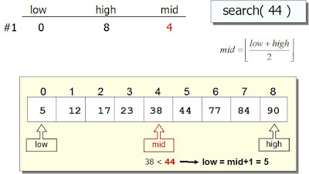
Figure 1 – Algorithm Discussion.
When we apply binary search to an array, we repeatedly divide it into individual search intervals, just like in the dictionary example. The original array is initially the search interval. If the desired item's value is less than the item in the middle of the interval, the search interval is the array with items less than the middle item. Similarly, if the desired item is greater than the item in the middle, the search interval is the array containing items greater than the middle item.
After each iteration, you eliminate half of the array elements. This means that if the array contains 100 elements, it will take O(log2 100) iterations to find the value or confirm that it does not exist in the array.
Binary search is naturally a recursive algorithm because what you're doing is essentially a binary search at smaller input after each iteration, but in this program, you'll implement binary search without recursion.
There are three cases used in the binary search:
Case 1: data<a[mid] then left = mid+1.
Case 2: data>a[mid] then right=mid-1
Case 3: data = a[mid] // element is found
In the preceding example, 'a' is the name of the array, mid is the recursively calculated index of the element to be searched, data is the element to be searched, left denotes the left element of the array, and right denotes the element that occurs on the right side of the array.
Let's look at an example to see how binary search works:
- Assume we have a 10-dimensional array with indices ranging from 0 to 9, as shown in the figure below:
- We want to find 70 elements in the above array.
Step 1: First, we compute the array's middle element. We look at two variables: left and right. As shown in the figure below, left = 0 and right = 9.
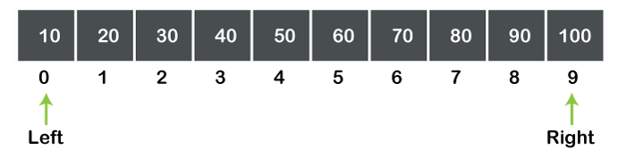
Figure 2 – Algorithm Discussion.

The middle element value can be calculated as:

As a result, mid = 4 and a[mid] = 50. Because the element to be searched is 70, a[mid] does not equal data. Case 2 is satisfied, namely, data>a[mid].
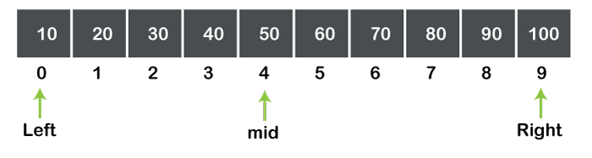
Figure 3 – Algorithm Discussion.
Step 2: Because data>a[mid], the value of left is increased by mid+1, i.e., left=mid+1. Because the value of mid is 4, the value of left becomes 5. We now have a subarray, as shown in the figure below:
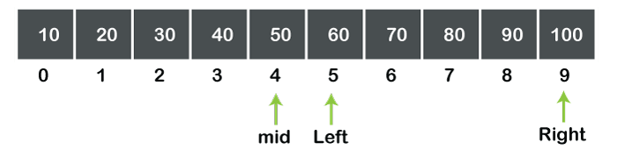
Figure 4 – Algorithm Discussion.
Using the above formula, the mid-value is calculated once more, and the value of mid becomes 7. The midpoint is now represented as:

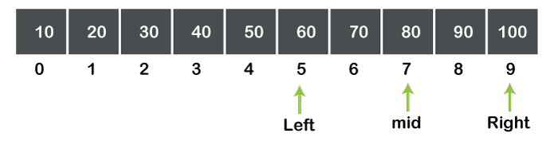
Figure 5 – Algorithm Discussion.
We can see in the above figure that a[mid]>data, so the value of mid will be calculated in the next step.
Step 3: The value of right is decremented by mid-1 as a[mid]>data. Because the value of mid is 7, the value of right is 6. The array can be written as:
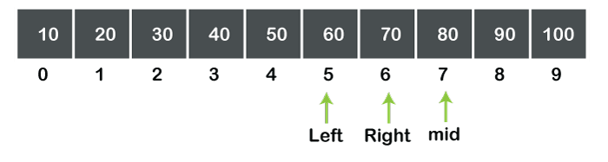
Figure 6 – Algorithm Discussion.
The mid value will be calculated once more. Left and right have values of 5 and 6, respectively. As a result, the value of mid is 5. The midpoint can now be represented in an array, as shown below:

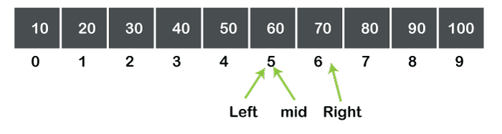
Figure 7 – Algorithm Discussion.

We can see in the above figure that a[mid]data.
Step 4: The left value is incremented by mid+1 as a[mid]data. Because the value of mid is 5, the value of left is 6.
The value of mid is now calculated again using the previously discussed formula. Because the values of left and right are 6 and 6, respectively, the value of mid becomes 6, as shown in the figure below:
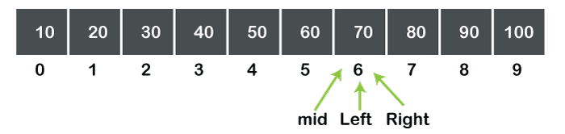
Figure 8 – Algorithm Discussion.
In the above diagram, we can see that a[mid]=data. As a result, the search is complete, and the element is successfully located.
Comparison with Linear Search:
Linear search is a search that finds an element in a list by searching the element sequentially until the element is found in the list. A binary search, on the other hand, is a search that finds the middle element in a list recursively until the middle element matches a searched element.
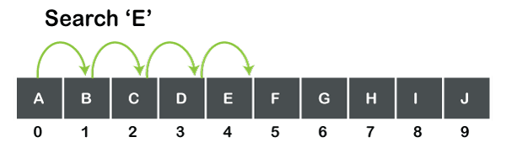
Figure 9 – Algorithm Discussion.
The image above depicts a character type array with ten values. If we want to search for 'E,' the search begins with the 0th element and continues until the element, i.e., 'E,' is not found. We can't just jump from the 0th to the 4th element; instead, each element is scanned one by one until the element isn't found.
As a linear search, each element is scanned one by one until the element is not found. When the number of elements increases, so does the number of elements to be scanned. The time required to search for elements is proportional to the number of elements. As a result, the worst-case complexity is O.

Table 3. Differences of Linear and Binary Search
Basis of comparison | Linear Search | Binary Search
Definition | The linear search begins with the first element and compares each element to a previously searched element until the element is not found. | It determines the position of the searched element by locating the array's middle element.
Sorted Data | The elements in a linear search do not have to be arranged in sorted order. | The elements must be arranged in sorted order as a prerequisite for the binary search.
Implementation | Any linear data structure, such as an array or linked list, can be used to implement the linear search. | Binary search implementation is limited because it can only be implemented on data structures with two-way traversal.
Approach | It employs a sequential approach. | It is built on the divide and conquer strategy.
Size | It is better suited for small data sets. | Binary search implementation is limited because it can only be implemented on data structures with two-way traversal.
Efficiency | It is less efficient when dealing with large data sets. | It is more efficient when dealing with large data sets.
Worst-case scenario | The worst-case scenario for finding the element in a linear search is O. | The worst-case scenario for finding the element in a binary search is O. (log2n).
Base-case scenario | The best-case scenario for finding the first element in a list in a linear search is O. | The best-case scenario for finding the first element in a list in a binary search is O. (1).
Dimensional Array | It can be used on a single or multidimensional array. | It can only be used on a multidimensional array.

Diagrams
- System Architecture
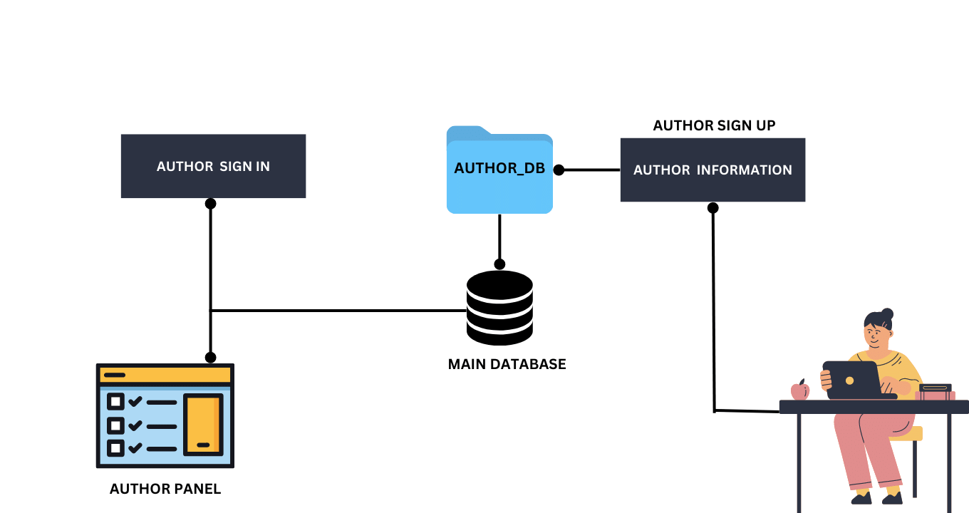
Figure 10 – Account Creation for Author/Sub-admin
Figure 10 illustrates the process in each division and organization, only the sub-admin who is specifically allocated to that unit will be able to submit articles. The sub-duties administrator's will include the writing of articles, the uploading of notices and tales, and the creation of stories for each specific department and group at Taguig City University which authors can create an account to upload their articles.
After the sub admin has registered an account, he or she will be sent to the panel where articles may be posted after the account has been activated. However, even if a sub admin attempts to upload an article, the piece will not be made available to the general public until the main admin checks it over and confirms that it may be made public.
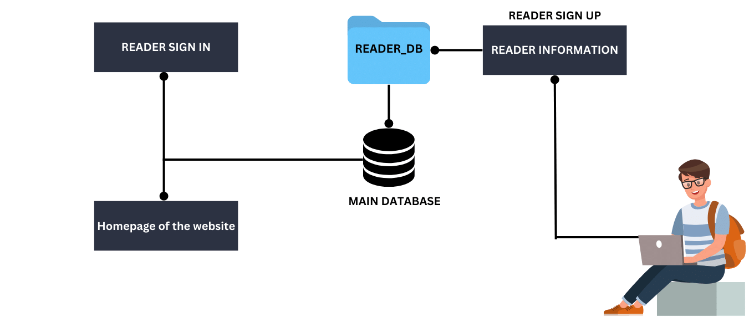
Figure 11 – Account Creation for Reader/User
The process of creating an account for a reader is quite similar to that of an author. If the reader does not already have an account, the first step is for them to sign up for one and then sign in. There is no need to sign up for an account in order to read an item from NewsGrid. Despite this, there are a few functions that the user or the reader won't be able to access. For example, including it in the bookmark and downloading the article to your computer.
In addition, making a user account is completely voluntary and not required. It is up to the user to decide whether they want to bookmark a particular item or if they need to download the complete article for whatever reason. Both options are available to them.
Technicality of the Project
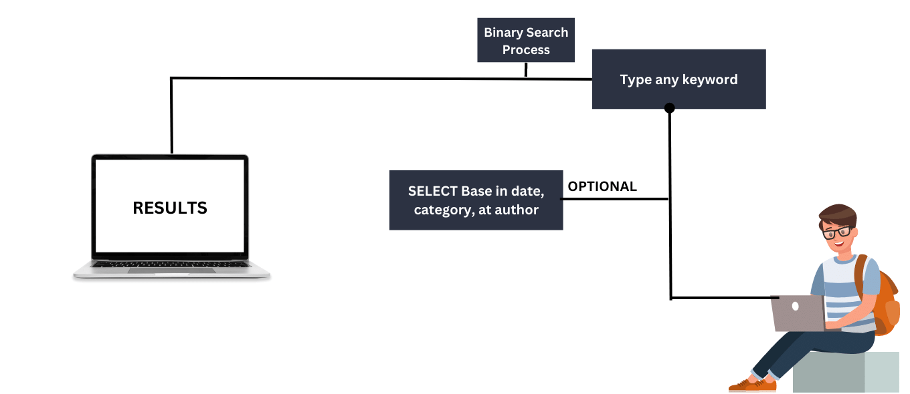
Figure 12 – Database Network
The purpose of this research is to provide a user-friendly method of locating a certain article via the use of an existing algorithm called Binary Searching for Keyword-Based Searching. Users that are connected to the same network are able to access the web application thanks to the system that is built within the web application itself.
The amount of information that has to be searched is cut in half with each step of a binary search, which is one of the primary reasons why this kind of search is much faster than a serial search. It is conceivable, for instance, to search among 1024 values and locate the one you want in as little as ten steps, each and every time.
NewsGrid has the following options for locating an article:
- Basic search using keywords, which binary search algorithm implemented.
- Utilizing the categories of Department and Organization respectively.
- Finding an article through its publication date.
- By following current trends in order to find an article.
Database Network
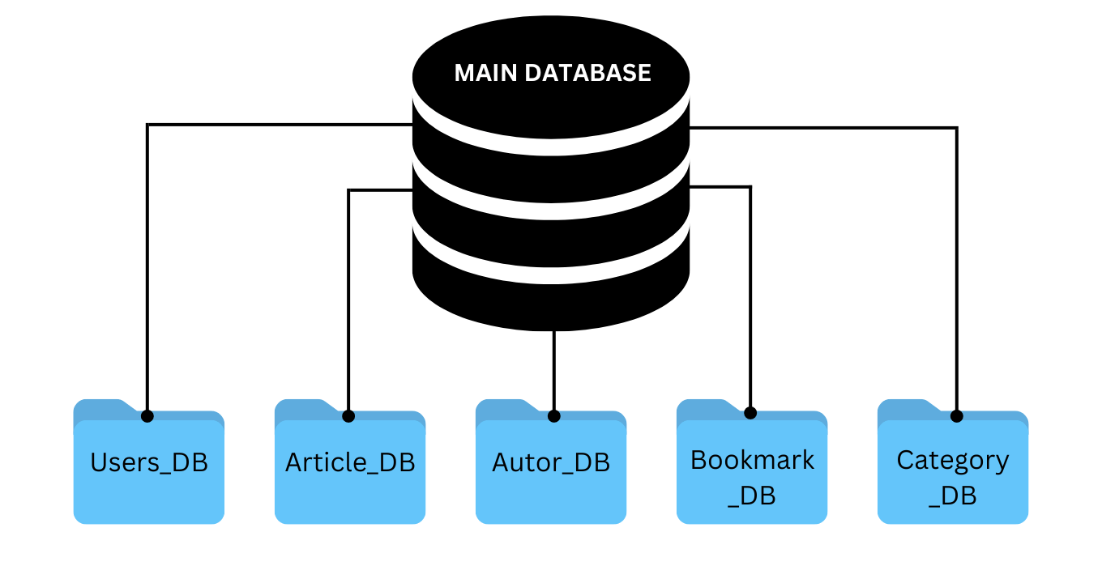Figure 13 – Database Network
Figure depicts how databases are linked together. Each Research and Account Database has a primary backup in the Main database. Account databases will store administrative (DB) and user information and author (DB). Others include Article(DB), Bookmark(DB), and Category(DB). The Article database will include article description, article title, and the banner. The article database contains the entire news or media information for each individual category, including department and organization.
The NewsGrid has a 3 separate login and registration form. The first one is the reader, they can view, add to bookmark, and download the article. The other one is the author, the author will be the representative or sub admin that is assigned to post an article and news on the website. The last one is the main admin of the website. The MIS department will be responsible for managing the system for being the main admin of NewsGrid.
- Data Flow Diagram
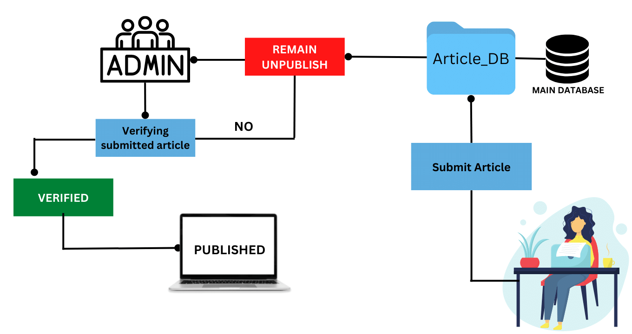
Figure 14 – Data Flow Diagram of Submitting Article Process
Figure 14 shows how the article is being submitted and stored in a database, which the admin handles to publish the article information. Once the article is submitted by the student, it will go directly to the Article_DB. However, the article will remain unpublished and not visible to the users. The visibility of the article will remain available to the admin assigned until he/she verifies the uploaded article first before it is actually published and visible to everyone.
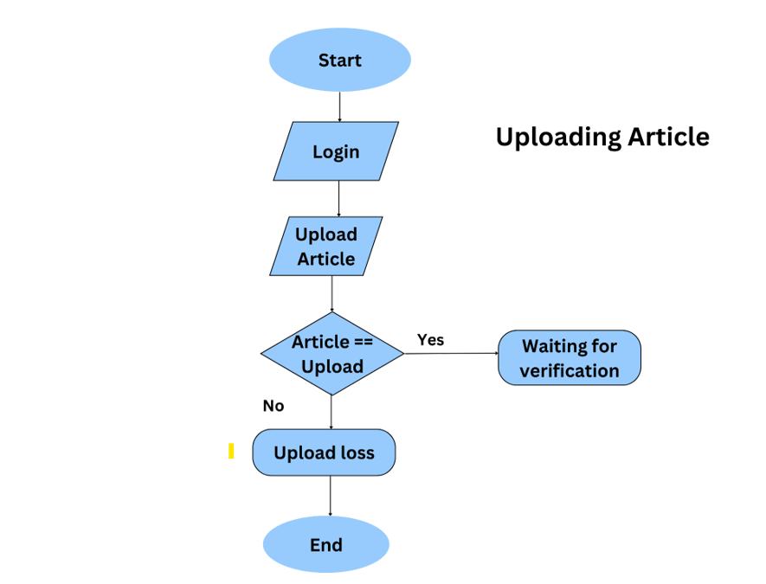
If the uploaded article is not verified by the representative admin, it will remain unpublished until the admin verifies or deletes it for a valid reason. The admin cannot edit and modify the content of the article, however, the admin can decide the visibility of the article by publishing/unpublishing the content. Of course, he/she can also delete the content for valid purposes.
- Flow Chart

Figure 15 – Flowchart Sub-admin/Author Uploading Article
The workflow for uploading an article from Author may be seen in the figure to the right. On the other hand, after the author has published the article, the system will send a message to the administrator of the MIS, asking them to examine the document that the author has uploaded.
When posting an article, the author is expected to adhere to the required minimum number of characters. In this format, the title must have a minimum of 30 characters, while the description must have a minimum of 1000 characters. This is for the normal publishing to the NewsGrid that every Author from the Department was required to follow.
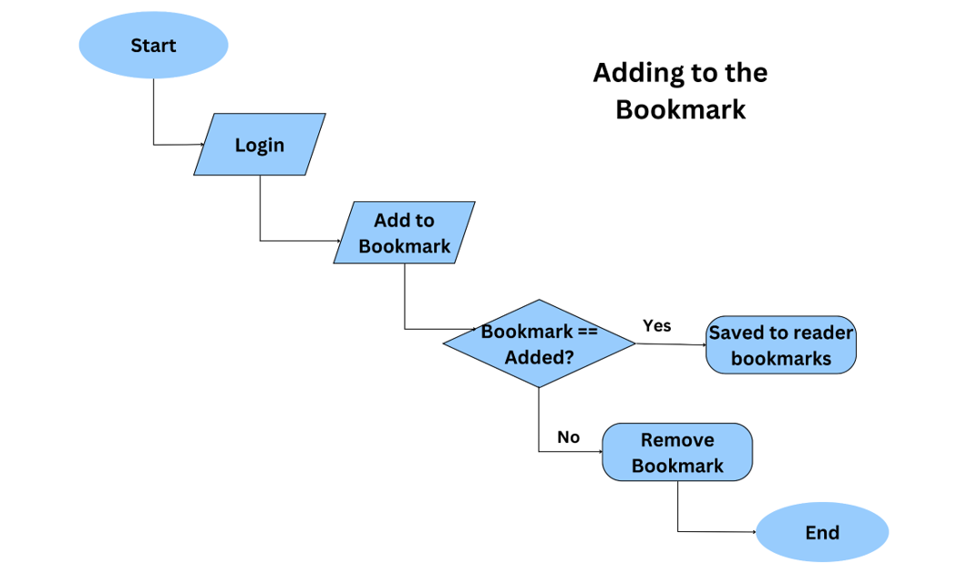

Figure 16 – Flowchart User/Reader Bookmarking an Article

The following features allow the reader to select whether or not they would want to add an article to their bookmarks for future reference; the figure provides an illustration of how this is done. The reader has the ability to add several articles from each category to their bookmarks without having to delete the one they just added.
On the other hand, if the article were to be removed off the website, NewsGrid. It will also delete the article that was bookmarked after it was added. This will rely on the Administrator and their decision about whether or not the article will be removed from the website.
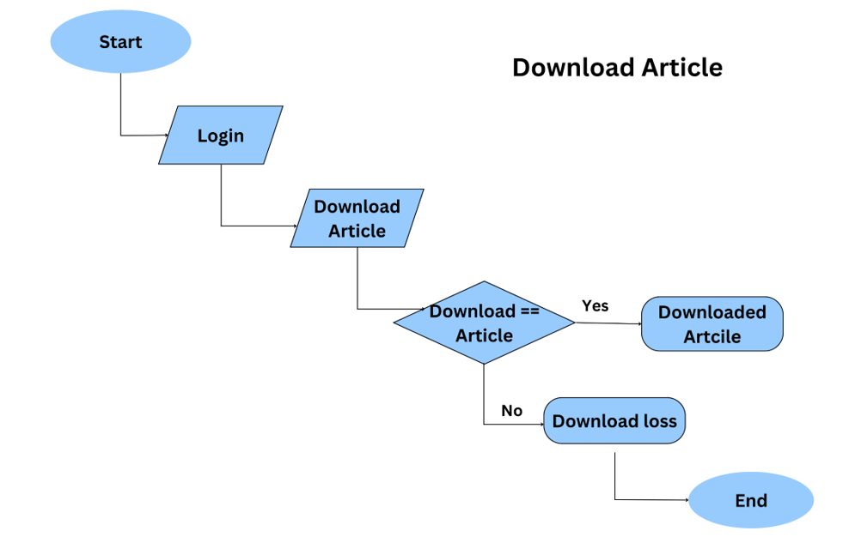

Figure 17 – Flowchart User/Reader Downloading an Article
The viewer is given the opportunity to download a particular article from the department of their choosing while seeing this figure. The user will be able to preserve a hardcopy of the article for their own personal reference in the future thanks to this function. After the reader or user selects the download option from inside the article, it will open a new tab in which the embedded pdf may be seen. The downloaded article is generated from a pdf.
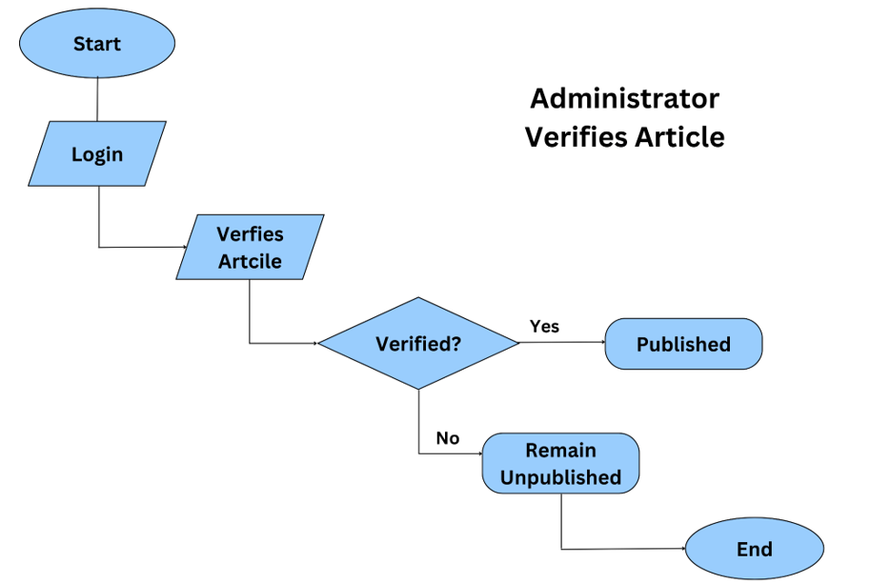
When an article is downloaded, a watermark representing the institution of Taguig City University appears. This is done to protect the article and the author from theft and fraud. These capabilities are provided by NewsGrid in order to improve the trustworthiness of each article that is downloaded by the reader and users.

Figure 18 – Flowchart Admin Verifying Article
In this figure, the administrator is checking the article that the Author has uploaded and filed. This is done to avoid fraud as well as anything that is harmful coming from the article that is uploaded. The Administrator has the authority to exercise control over the article by examining its components and obtaining confirmation of its accuracy from the authors who were tasked with writing it for each division.
- Unified Modeling Language (UML)
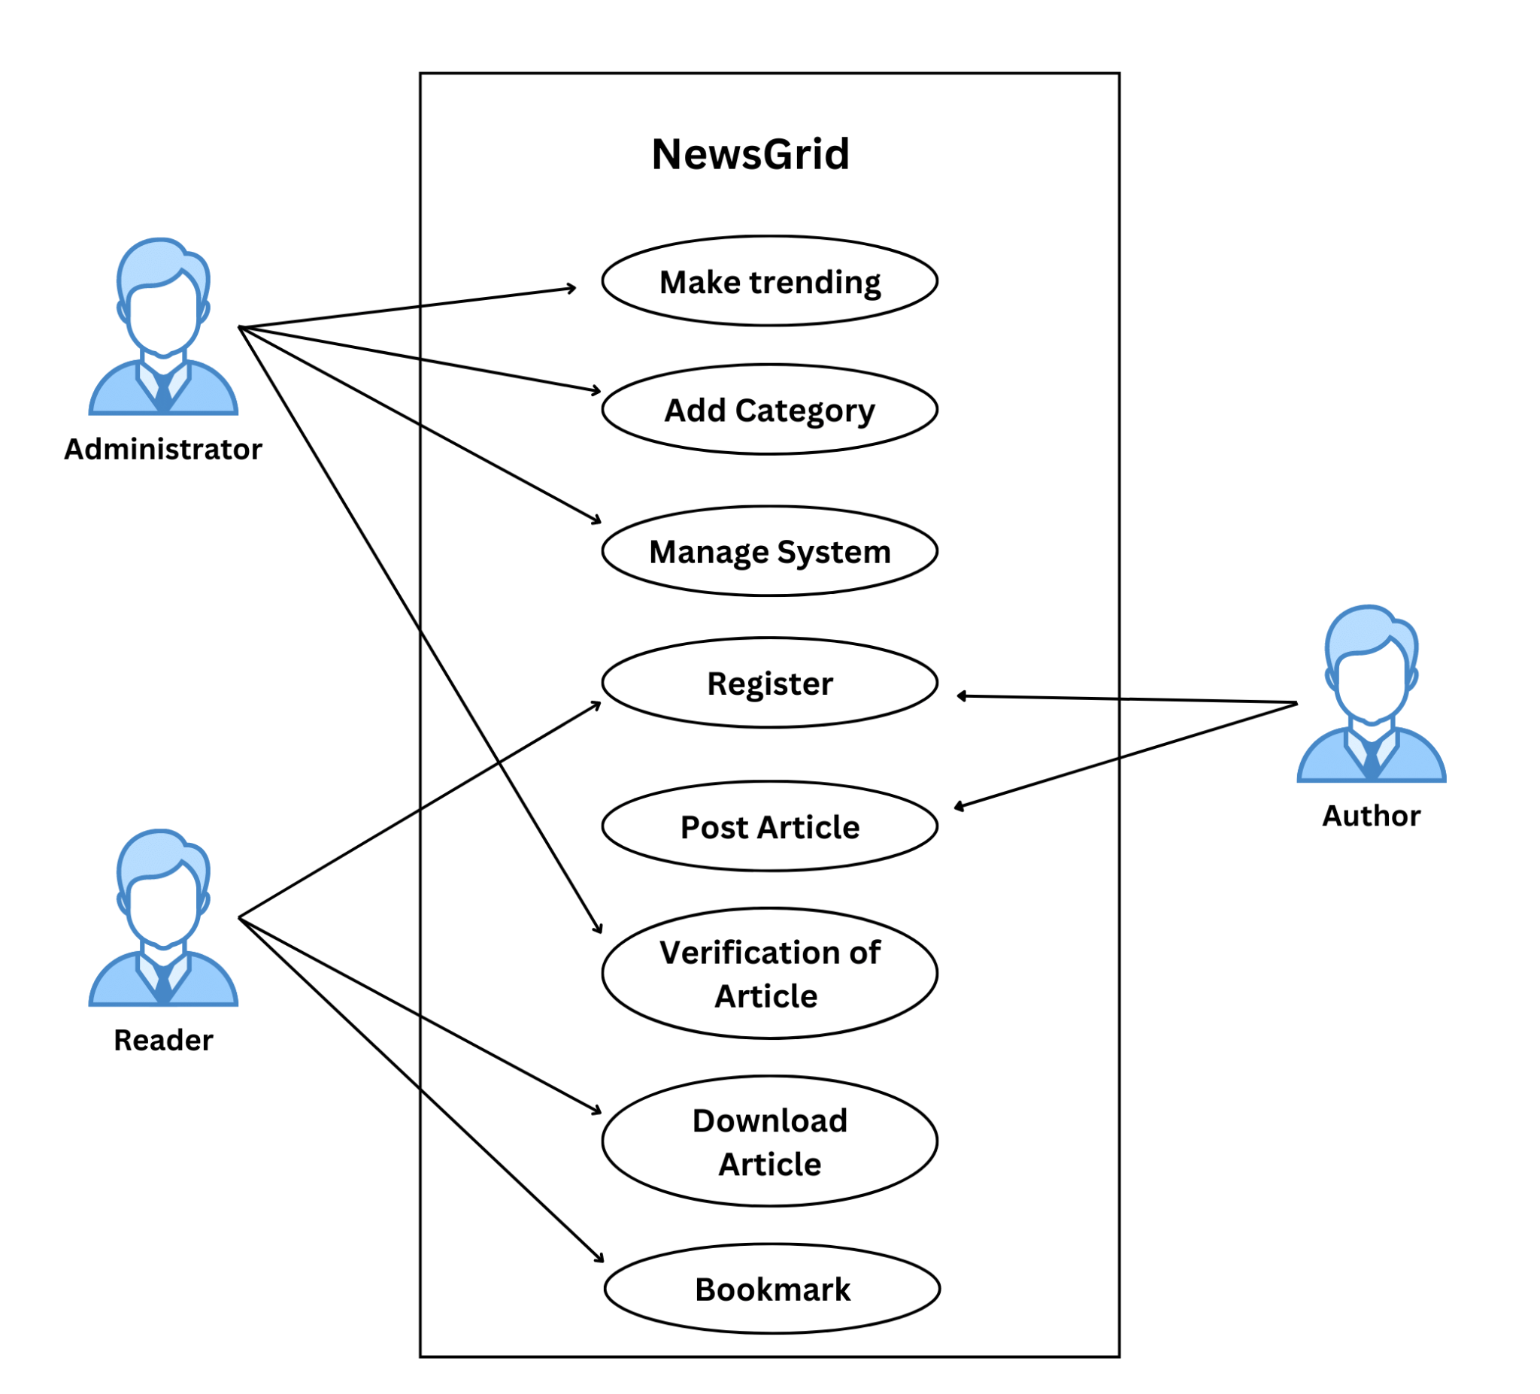Figure 19 – UML Use-Case Diagram
Researchers and developers now have access to a visual language called NewsGrid, which makes it possible for them to create, record, and display software systems. UML is not a programming language; nonetheless, it may give visual representations that assist software developers in better comprehending the possible outcomes of their programs as well as any problems that may occur.
The UML diagram for the Use-Case that the Administrator, Reader, and Author limitation in those features introduced to the website NewsGrid is shown in this image. The Administrator is accountable for maintaining the system, creating categories, verifying articles that were submitted by authors, and determining which articles are trending in the system. While it is the Author's responsibility to publish articles and, of course, establish an account with the NewsGrid system, the Author is responsible only for posting articles. Registering an account, saving the article as a bookmark, and downloading the article are all included in the reader scope.
- System Development
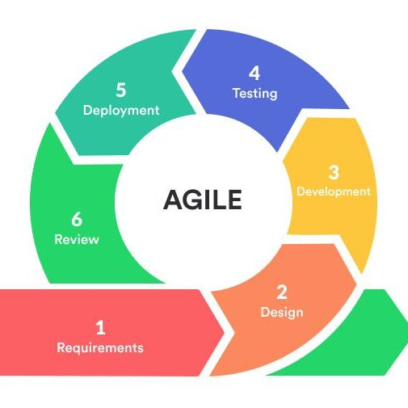
Figure 20 – System Development Agile Methodology
This Figure 20 shows the project development approach to be used in building One Id system. The waterfall model depicts the software development process in a sequential linear flow. This means that any phase of the development process can begin only after the previous phase has been completed. The phases in this waterfall model do not overlap.
The agile model phases include:
Requirement Analysis
During the phase of NewsGrid development, all potential system requirements are captured and documented in a requirement specification document. Agile requirements, such as functions, services, and features, are critical components of a successful product. Agile requirements can be developed by teams as business rules, functions, or constraints to guide them through the production process.
Design
Clearly indicates that the designers of NewsGrid should maintain constant collaboration with the other members of the team (developers, layout specialists, etc.). This helps members of the team feel more at ease with one another and increases their feeling of ownership over the project.
Development
A procedure or group of procedures for NewsGrid procedures used in the creation of software Again, this is a very general definition, but it does include aspects such as the design phase and the development phase. This is a way of thinking about things such as the waterfall process, which is not an iterative one. In most cases, it will be organized into distinct stages.
Testing
Testing software is just one component of the larger software development lifecycle in an agile context. The NewsGrid will take place concurrently with the development of the product and is a collaborative effort that involves not only testers and developers but also product owners and even end customers.
Deployment
The method by which programmers distribute software to end users, including programs, modules, updates, and patches Both the rate at which the website NewsGrid is able to adapt to shifting user preferences and needs, as well as the quality of each adjustment, are impacted by the processes that are followed by developers while writing, testing, and deploying new code.

Details of technology to be Used

Visual Studio Code
Microsoft Visual Studio Code is a source-code editor available for Windows, Linux, and macOS. Support for debugging, syntax highlighting, intelligent code completion, snippets, code refactoring, and embedded Git are among the features. Free. Based on open source code. Runs around everywhere. You agree to the license and privacy statement by using VS Code.

PHP
PHP is an HTML-enabled server-side scripting language. It is used to manage dynamic content, databases, session tracking, and even to create entire e-commerce websites. It is compatible with many popular databases, including MySQL, PostgreSQL, Oracle, Sybase, Informix, and Microsoft SQL Server. You can easily accomplish this by including the router file. As you can see, the PHP built-in web server is a simple web server with no complicated configurations. It is ideal for use in development and testing.

Xdebug
A PHP plugin known as Xdebug offers tools for debugging as well as benchmarking the program. It relies on the debugging protocol known as DBGp. The Xdebug PHP plugin provides users with tools for both debugging and benchmarking the software they are working with. It is dependent on the debugging protocol that is often referred to as DBGp.

GIT Command Bash
Git is a free and open source software for distributed version control, which tracks changes in any set of files and is commonly used to coordinate work among programmers who are collaboratively developing source code during software development.

MySQL
MySQL is a database management tool, so while it is not a database, it is widely used in relation to managing and organizing data in databases. MySQL is a database, not a programming language. It's a database management system, more specifically an RDBMS. It manages data inside the database using SQL (Structured Query Language), which is a query language. MySQL, an open-source Oracle-backed Relational Database Management System, was created in 1995.

XAMPP
XAMPP stands for cross-platform, Apache, MySQL, PHP, and Perl, and it allows you to build a WordPress site offline, on your computer's local web server. This simple and lightweight solution is cross-platform, meaning it works on Windows, Linux, and Mac.

CHAPTER IV
CHAPTER V

